Coral Reef Snorkeler Visitor Pledge

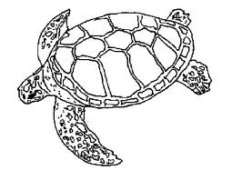

Most visitors to coral reefs never touch, kick, or stand on the coral. They are careful not to stir up the sand near the coral with their fins. Coral are fragile and, if injured, are slow to recover. Keeping a safe distance from the reef is the best way to ensure these beautiful reefs are here for future generations. If you need to fix your mask or snorkel, it is best to swim away from the reef first.

I pledge to be a responsible visitor to the reef by:
- Being aware of where my fins are at so I don’t kick the coral
- Treading water instead of standing on the reef
- Not stirring up silt near the reef
- Keeping a safe distance from all marine organisms

